**Observation 40-theatres**

Create theatre:

CREATE TABLE Theater (

TheaterID INT PRIMARY KEY,

Name VARCHAR(100),

Location VARCHAR(100)

);

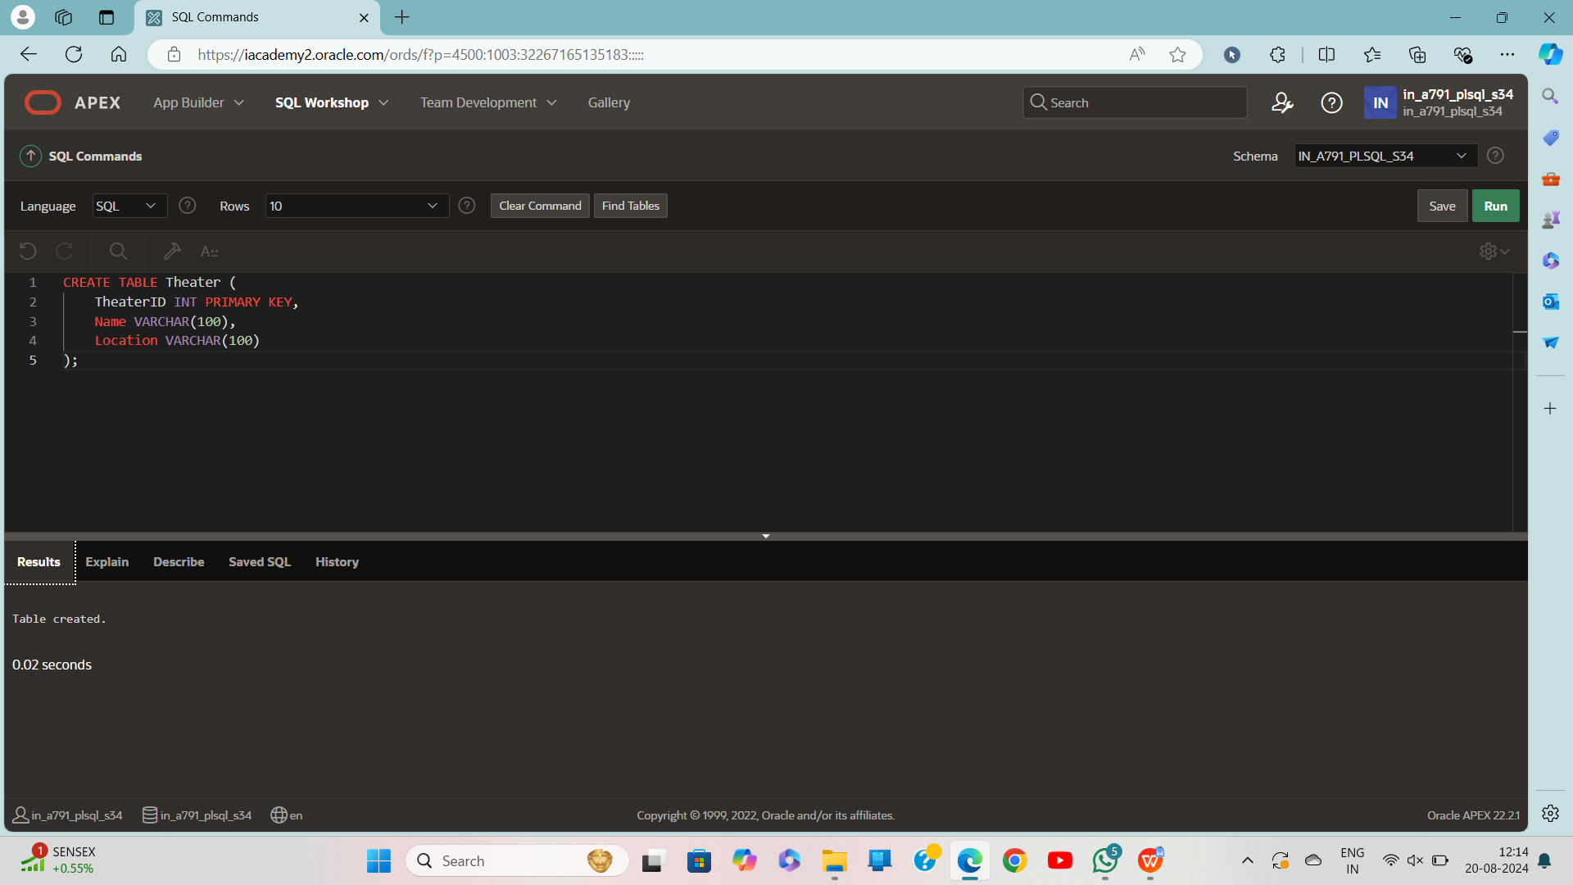

Create shows:

CREATE TABLE Show (

ShowID INT PRIMARY KEY,

TheaterID INT,

ShowDate DATE,

StartTime TIMESTAMP,

EndTime TIMESTAMP,

MovieName VARCHAR2(100),

TicketPrice DECIMAL(10,2),

TotalSeats INT,

FOREIGN KEY (TheaterID) REFERENCES Theater(TheaterID)

);

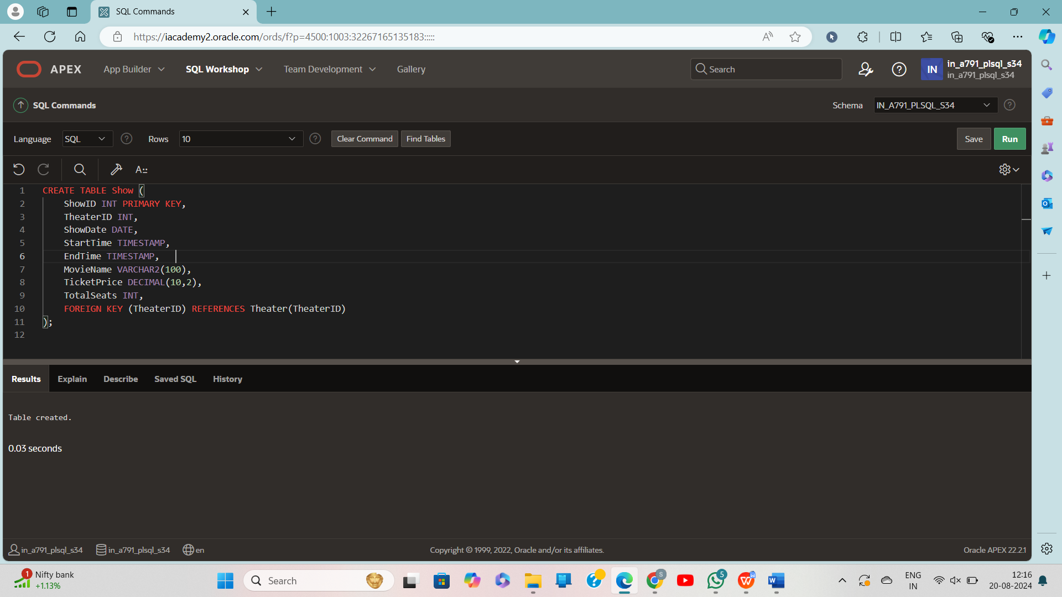

CREATE TABLE Ticket (

TicketID INT PRIMARY KEY,

ShowID INT,

PurchaseDate DATE,

Quantity INT,

FOREIGN KEY (ShowID) REFERENCES Show(ShowID)

);

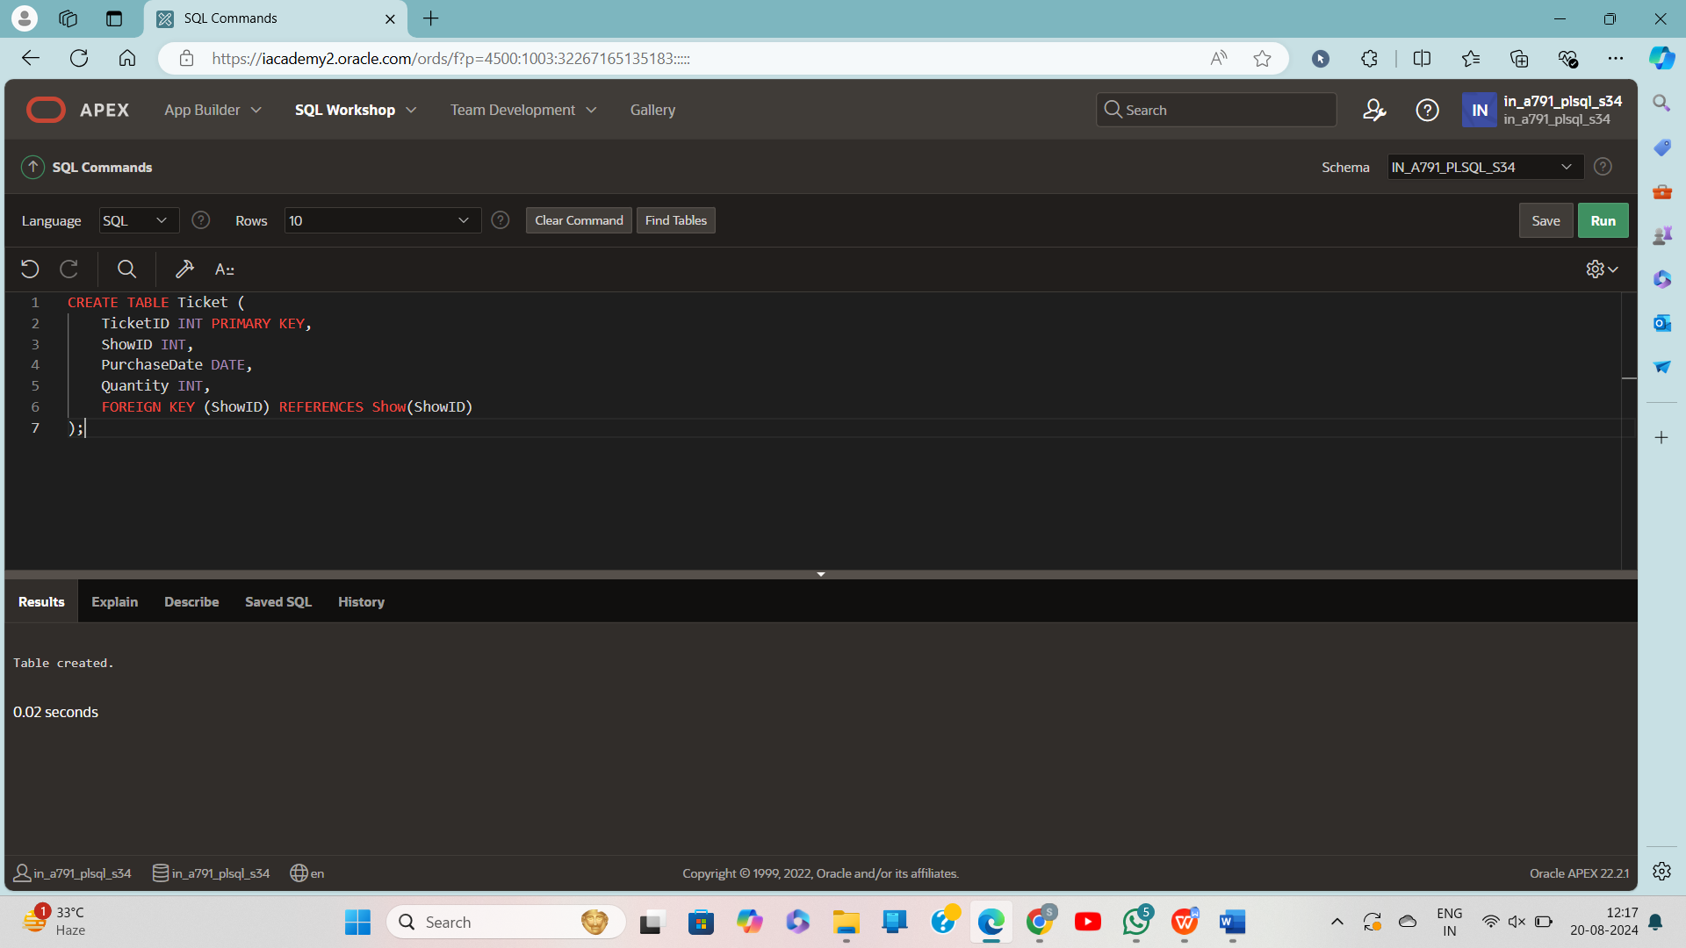

CREATE TABLE ProfitLoss (

ProfitLossID INT PRIMARY KEY,

ShowID INT,

CalculationDate DATE,

ProfitOrLossAmount DECIMAL(10,2),

FOREIGN KEY (ShowID) REFERENCES Show(ShowID)

);

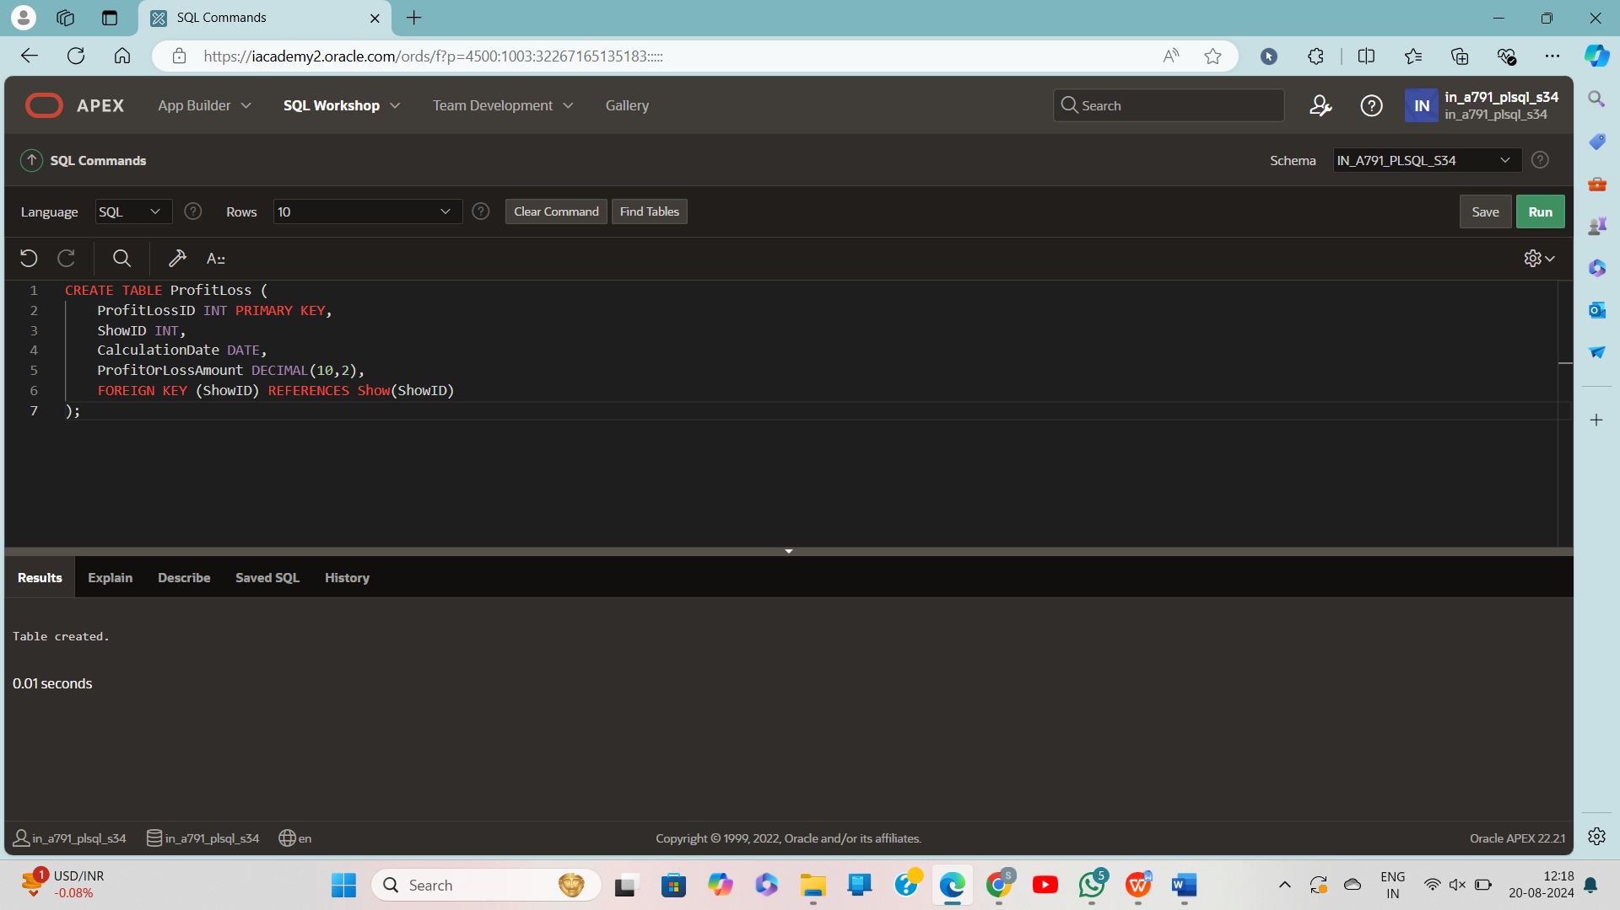

INSERT INTO Theater (TheaterID, Name, Location) VALUES (1, 'Grand Cinema', 'Downtown');

INSERT INTO Theater (TheaterID, Name, Location) VALUES (2, 'Mega Movies', 'Uptown');

INSERT INTO Theater (TheaterID, Name, Location) VALUES (3, 'City Lights', 'Suburbs');

INSERT INTO Show (ShowID, TheaterID, ShowDate, StartTime, EndTime, MovieName, TicketPrice, TotalSeats)

VALUES (1, 1, DATE '2024-08-20', TO_TIMESTAMP('18:00:00', 'HH24:MI:SS'), TO_TIMESTAMP('20:00:00', 'HH24:MI:SS'), 'Inception', 12.50, 200);

INSERT INTO Show (ShowID, TheaterID, ShowDate, StartTime, EndTime, MovieName, TicketPrice, TotalSeats)

VALUES (2, 2, DATE '2024-08-21', TO_TIMESTAMP('19:00:00', 'HH24:MI:SS'), TO_TIMESTAMP('21:30:00', 'HH24:MI:SS'), 'The Matrix', 15.00, 150);

INSERT INTO Show (ShowID, TheaterID, ShowDate, StartTime, EndTime, MovieName, TicketPrice, TotalSeats)

VALUES (3, 3, DATE '2024-08-22', TO_TIMESTAMP('20:00:00', 'HH24:MI:SS'), TO_TIMESTAMP('22:15:00', 'HH24:MI:SS'), 'Interstellar', 14.00, 180);

INSERT INTO Ticket (TicketID, ShowID, PurchaseDate, Quantity)

VALUES (1, 1, TO_DATE('2024-08-19', 'YYYY-MM-DD'), 50);

INSERT INTO Ticket (TicketID, ShowID, PurchaseDate, Quantity)

VALUES (2, 1, TO_DATE('2024-08-20', 'YYYY-MM-DD'), 100);

INSERT INTO Ticket (TicketID, ShowID, PurchaseDate, Quantity)

VALUES (3, 2, TO_DATE('2024-08-20', 'YYYY-MM-DD'), 75);

INSERT INTO Ticket (TicketID, ShowID, PurchaseDate, Quantity)

VALUES (4, 3, TO_DATE('2024-08-21', 'YYYY-MM-DD'), 120);

INSERT INTO ProfitLoss (ProfitLossID, ShowID, CalculationDate, ProfitOrLossAmount)

VALUES (1, 1, TO_DATE('2024-08-20', 'YYYY-MM-DD'), 1000.00);

INSERT INTO ProfitLoss (ProfitLossID, ShowID, CalculationDate, ProfitOrLossAmount)

VALUES (2, 2, TO_DATE('2024-08-21', 'YYYY-MM-DD'), 500.00);

**Create sequence:**

CREATE SEQUENCE ProfitLoss_SEQ

START WITH 1

INCREMENT BY 1

NOMAXVALUE

NOCYCLE

CACHE 20;

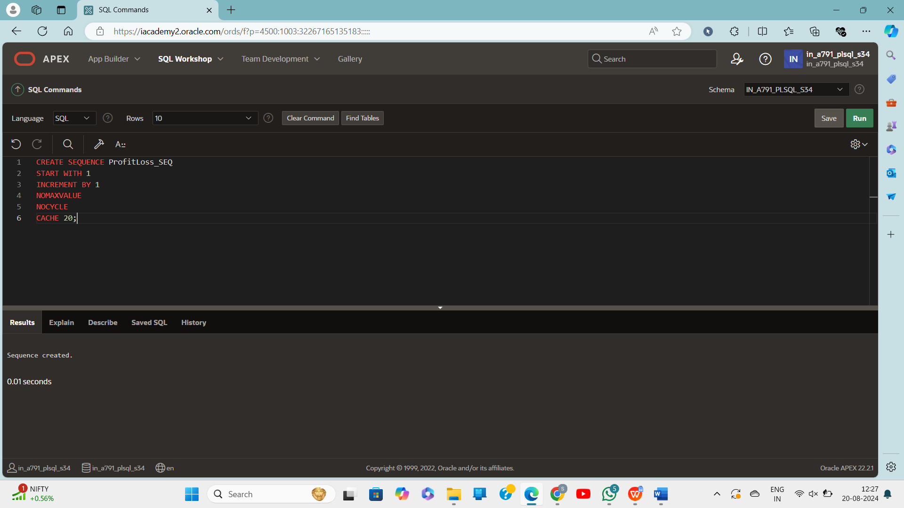

CREATE OR REPLACE PROCEDURE CalculateProfitLoss (p_ShowID IN INT, p_CalculationDate IN DATE) IS

v_TotalTicketsSold INT := 0;

v_TotalRevenue DECIMAL(10,2) := 0;

v_TotalSeats INT;

v_TicketPrice DECIMAL(10,2);

v_ProfitOrLoss DECIMAL(10,2);

BEGIN

-- Get the total tickets sold for the show

SELECT COALESCE(SUM(Quantity), 0)

INTO v_TotalTicketsSold

FROM Ticket

WHERE ShowID = p_ShowID;

-- Get the ticket price and total seats from the Show table

SELECT TicketPrice, TotalSeats

INTO v_TicketPrice, v_TotalSeats

FROM Show

WHERE ShowID = p_ShowID;

-- Calculate total revenue

v_TotalRevenue := v_TotalTicketsSold * v_TicketPrice;

-- Assuming profit is revenue - (total seats * some cost per seat, let's assume a fixed cost of 50)

v_ProfitOrLoss := v_TotalRevenue - (v_TotalSeats * 50);

-- Output the results

DBMS_OUTPUT.PUT_LINE('Total Tickets Sold: ' || v_TotalTicketsSold);

DBMS_OUTPUT.PUT_LINE('Ticket Price: ' || v_TicketPrice);

DBMS_OUTPUT.PUT_LINE('Total Seats: ' || v_TotalSeats);

DBMS_OUTPUT.PUT_LINE('Total Revenue: ' || v_TotalRevenue);

DBMS_OUTPUT.PUT_LINE('Profit or Loss: ' || v_ProfitOrLoss);

-- Insert the profit or loss into the ProfitLoss table

INSERT INTO ProfitLoss (ProfitLossID, ShowID, CalculationDate, ProfitOrLossAmount)

VALUES (ProfitLoss_SEQ.NEXTVAL, p_ShowID, p_CalculationDate, v_ProfitOrLoss);

COMMIT;

EXCEPTION

WHEN NO_DATA_FOUND THEN

DBMS_OUTPUT.PUT_LINE('No data found for the given ShowID.');

WHEN OTHERS THEN

DBMS_OUTPUT.PUT_LINE('An error occurred: ' || SQLERRM);

END;

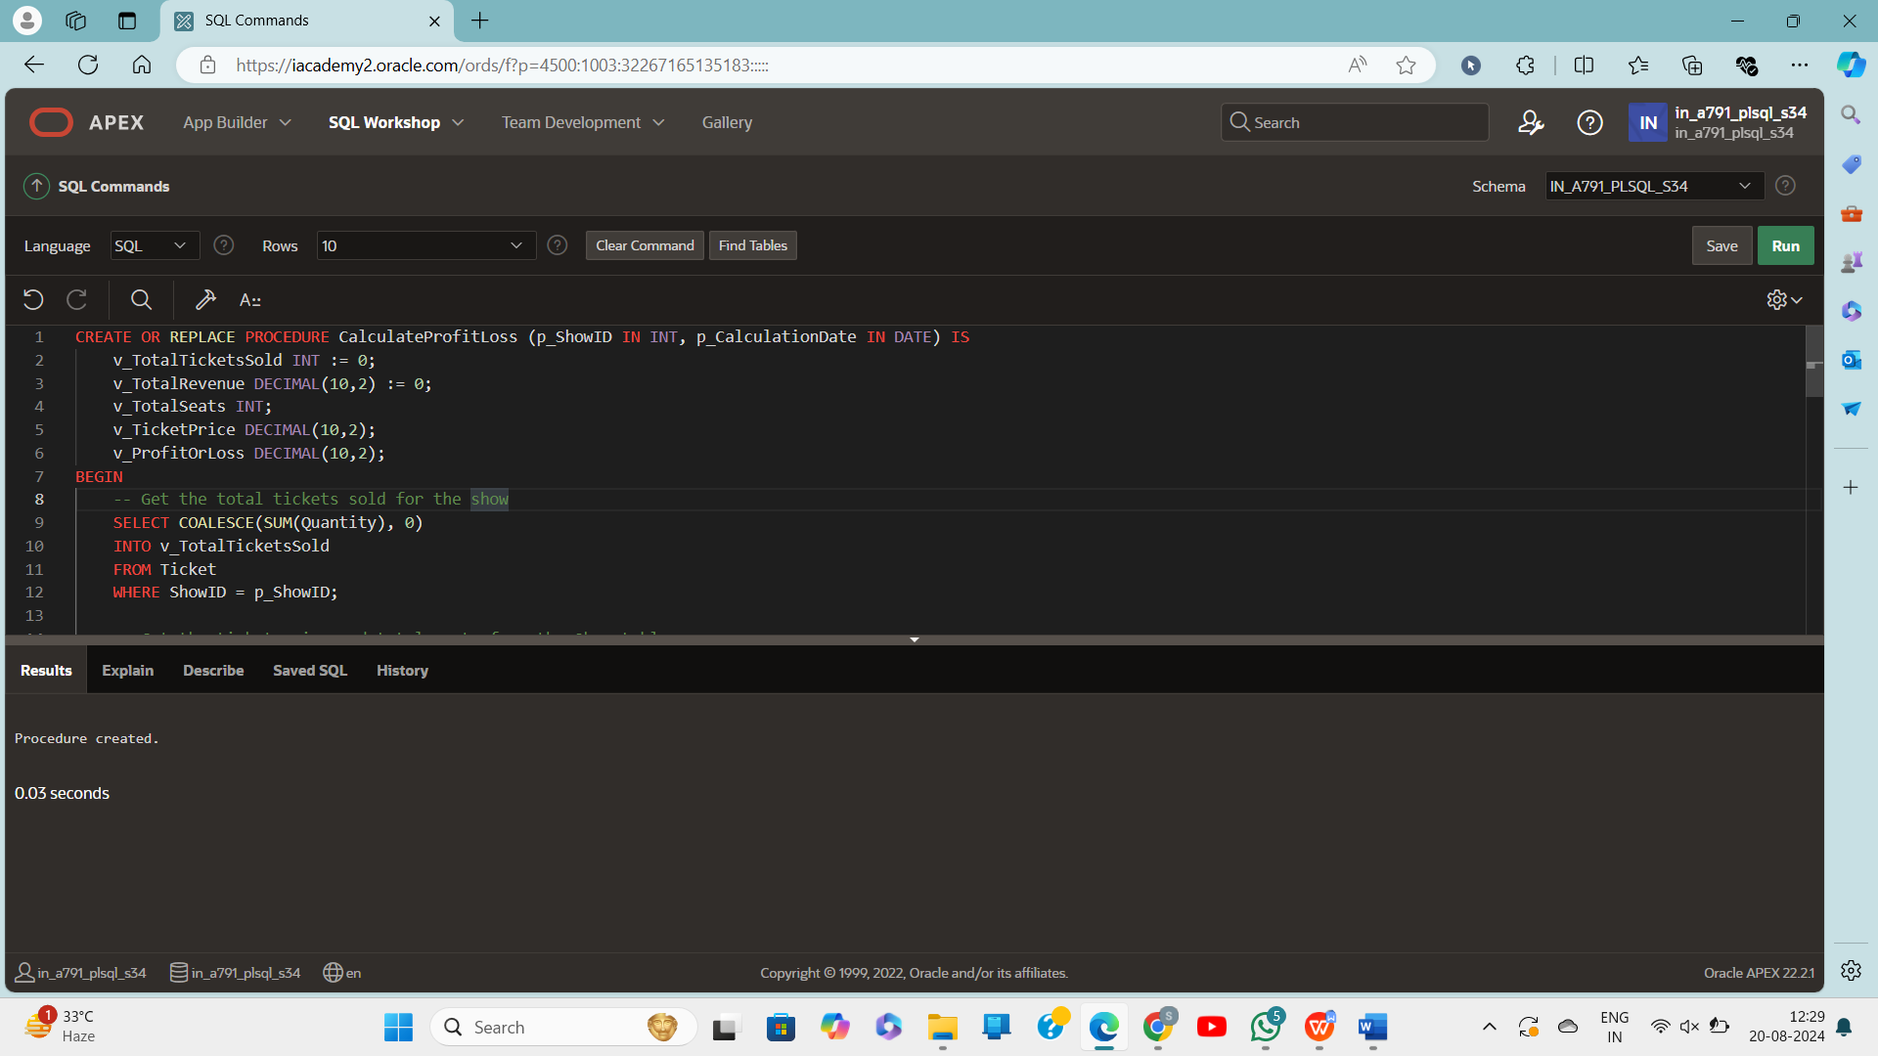

BEGIN

CalculateProfitLoss(1, TO_DATE('2024-08-20', 'YYYY-MM-DD'));

END;

